***Obstacle detector and distance measuring device.***

***Circuit diagram:***

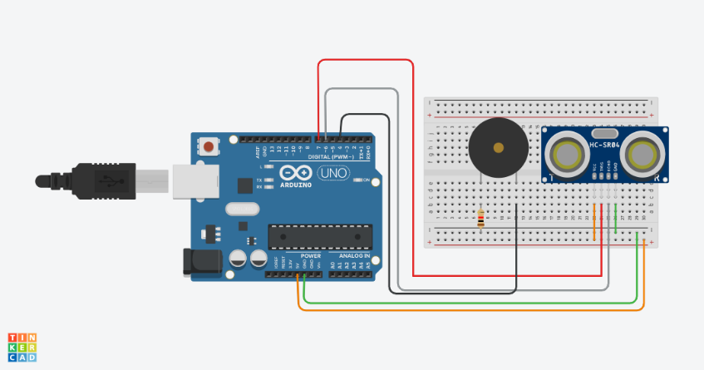

***THEORY:***

***Concept Used:-***

***In this project we have used a concept of ultrasonic object detector(sensor). It detects the person entering through some distance and then the buzzer gets on and runs for 2ms until another person enters .***

***LEARNING AND OBSERVATIOBS:***

***Learnings: -***

* ***How to make use of ultrasonic sensors for object detection and the concept of buzzers.***
* ***To do coding on Arduino software as well on tinkercad.***
* ***Compiling and uploading codes done on tinkercad.***
* ***Use of tinkercad for making hardware and software and multimeters (for resistance calculation).***
* ***Use od breadboard and to make and execute circuits on it.***

***Observations: -***

* ***Working of a software on tinkercad.***
* ***Ringing of buzzer when sensor detects some object.***
* ***Software and hardware used for making circuit.***

***PROBLEMS AND TROUBLESHOOTING:***

* ***Uploading and compiling of codes.***
* ***Checking connections and underlining defective buzzers or sensors.***
* ***Checking correct port for software on tinkercad and type of Arduino.***
* ***Correct working of various hardware and software used.***

***Precautions:***

* ***Don’t make loose connections.***
* ***Don’t connect Arduino to the respective pc until the circuit is complete.***
* ***Carefully look on the working of all the devices used while making circuit.***
* ***Carefully look on the working of ultrasonic sensors and buzzers.***

***Outcomes:***

* ***The circuit is complete and ringing of buzzer when ultrasonic sensor detects any object at a particular distance is observed.***
* ***Can be used also for security purpose for many places.***
* ***Can be used as a smart way to detect a person .***